**ESS General Testing Outline Document**

**1.** **General Testing Guidelines**

Define the scope of testing  
Defining the scope of testing involves identifying the specific features, functionalities, and components of a system to be tested, including the depth and breadth of testing activities. It ensures that all critical areas are covered and helps in allocating resources effectively.

Identify the testing objectives  
Identifying testing objectives involves determining the specific goals and outcomes expected from the testing process, such as verifying functionality, ensuring performance, and detecting defects. It helps in guiding the testing efforts and measuring success.

Establish testing criteria and standards  
Establishing testing criteria and standards involves defining the benchmarks and quality measures that the software must meet, including performance thresholds, security requirements, and compliance with industry standards. It ensures consistency and reliability in testing outcomes.

Ensure proper documentation of test plan, test cases and results  
Ensuring proper documentation of test plan that outlines project specific testing approach, test cases and results involves recording detailed descriptions of test scenarios, steps, and expected outcomes, along with actual results and any discrepancies. This practice facilitates traceability, accountability, and continuous improvement in the testing process.

Maintain clear communication among testing team members  
Maintaining clear communication among testing team members involves regularly sharing updates, challenges, and progress through meetings, reports, and collaborative tools. This practice ensures alignment, fosters teamwork, and enhances the overall efficiency of the testing process.

**2.** **Overview of Testing in ESS**

Introduction to ESS (Enterprise Software Solutions)

ESS team assists our clients, drug manufacturers, in marketing their pharmaceutical products to their target customers, including healthcare professionals (HCPs) who prescribe the drugs and patients who purchase and use the prescriptions.

We execute this by delivering a seamless, integrated experience across multiple channels of communication for our customers in the life sciences industry, aka the Omnichannel approach. This includes web sites, email, social media, and other digital channels.

Importance of testing in ESS  
  
Ensures Data Integrity and System Reliability: Accurate data processing and reliable system performance are crucial for informed decision-making and smooth operations.

Maintains Compliance and Security: Adhering to industry regulations and protecting sensitive data are essential for trust and legal compliance.

Optimizes User Experience: Seamless integration and performance across digital channels enhance user interactions and satisfaction.

Enhances Marketing Effectiveness: Targeted campaigns and continuous improvement based on user feedback boost engagement and marketing success.

Supports Healthcare Professionals and Patients: Reliable information and positive digital experiences aid healthcare professionals in prescribing and patients in using medications.

Key components and modules involved in testing

|  |  |  |
| --- | --- | --- |
| **Application/Component/Integration** | **Purpose** | **MODULE/S** |
| Data Ingestion and Storing Snowflake (OE DWH) | ESS owned data warehouse storing all data required for orchestrating journeys via GrowthLoop, AI recommendations, ACTICS, AFINITY and other data sources pulled for project purpose. | Orchestrate DTP  Orchestrate DTC  Orchestrate HCP |
| Destination management Console | ESS campaign management with i-frame integration with GrowthLoop audience builder. DM attributes are used in GrowthLoop as tags for Meta data tracking | Orchestrate DTP  Orchestrate DTC  Orchestrate HCP |
| GL Audience Builder | GrowthLoop Audience Platform is a group of customers whose actions, inactions or attributes match a set of criteria you've defined, sometimes known as segments or lists | Orchestrate DTP  Orchestrate DTC  Orchestrate HCP |
| GL Journey Builder | GrowthLoop journey builder helps orchestrate journeys across ESS entire Marketing stack | Orchestrate DTP  Orchestrate DTC  Orchestrate HCP |
| ESP-Salesforce Marketing Cloud | Used to deliver personalized customer  engagement with marketing software built on the CRM platform via emails | Orchestrate DTP  Orchestrate DTC  Orchestrate HCP |
| ESP-Iterable | ESS licensed email platform. Used to deliver personalized customer  engagement with marketing software via emails/SMS. | Orchestrate DTP  Orchestrate DTC  Orchestrate HCP |
| Veeva Salesforce | Built on the Salesforce Platform, Veeva CRM ​​is a cloud-based CRM part of Veeva’s Commercial Suite for life sciences, which delivers the accurate customer data and compliant content required to enable more effective customer engagement across multiple communication channels. | Orchestrate DTP  Orchestrate HCP |
| AWS instances | used to host scalable websites and applications, manage big data, and provide backup and disaster recovery solutions | Orchestrate DTP  Orchestrate DTC  Orchestrate HCP |
| API Integrations | Application integration protocol between systems to make REST/SOAP calls to retrieve/create/update data | Orchestrate DTP  Orchestrate DTC  Orchestrate HCP |
| POSTGRES (Application DB) | ESS owned Destination manager database data storing campaign details | Orchestrate DTP  Orchestrate DTC  Orchestrate HCP |
| OE Media Activation | Partner with Media vendors to target media activation on client provided target list via banner ads, e-new letters, etc | Orchestrate DTP  Orchestrate DTC  Orchestrate HCP |
| Content Management – Tagging & Tracking | ESS tagging and tracking playbook with end-to-end meta data tracking. Also used for reporting success measurement | Orchestrate DTP  Orchestrate DTC  Orchestrate HCP |
| AI NBE (Applied insights Next best action) | AI model to determine a consumer next best action for targeting to increase the sales revenue based on ACTICS, AFINITY and Consumer engagement across various channels. | Orchestrate DTP  Orchestrate DTC  Orchestrate HCP |
| EMAIL ACTIVATION (Iterable/SFMC/EPSILON) | Partner with Email vendors or use Eversana licensed vendor tool to build SAD specific journeys with email templates set up to target client provided list of consumers. | Orchestrate DTP  Orchestrate DTC  Orchestrate HCP |
| Pharmacy Intake | Eversana pharmacy prescription intake via fax, electronic transmission to create patient enrollment and order processing. | Orchestrate DTP |
| Digital Concierge (PWA) | Patient web application used by patient to track their prescription activities including the ability to transfer an Rx and apply for Co-pay. | Orchestrate DTP |
| TELEHEALTH Platform | Telehealth platforms use digital technologies to provide virtual medical services, including live video consultations, remote patient monitoring, and mobile health apps. They increase access to care, offer convenience, and improve efficiency by allowing patients to receive care from home. | Orchestrate DTP |
| Pharmacy Services (Ex: Amazon) | To track patient's medication shipment and delivery from vendor pharmacy dispense data | Orchestrate DTP |
| ESS TABLEAU Reporting | Client facing dashboards brand specific for overall orchestrate success measurement | Orchestrate DTP  Orchestrate DTC  Orchestrate HCP |
| Web (GA4) | Google analytics data to track vendor/client website activities performed by HCP or potential patient. | Orchestrate DTP  Orchestrate HCP |
| Data Feeds | Data feeds sent via secured transfer including metrics defined by the Client for reporting/tracking. | Orchestrate DTP  Orchestrate DTC  Orchestrate HCP |

**3. Sample Test Results Screenshot for Use Case (PASS/FAIL)**

Screenshot of SIT (System integration testing) results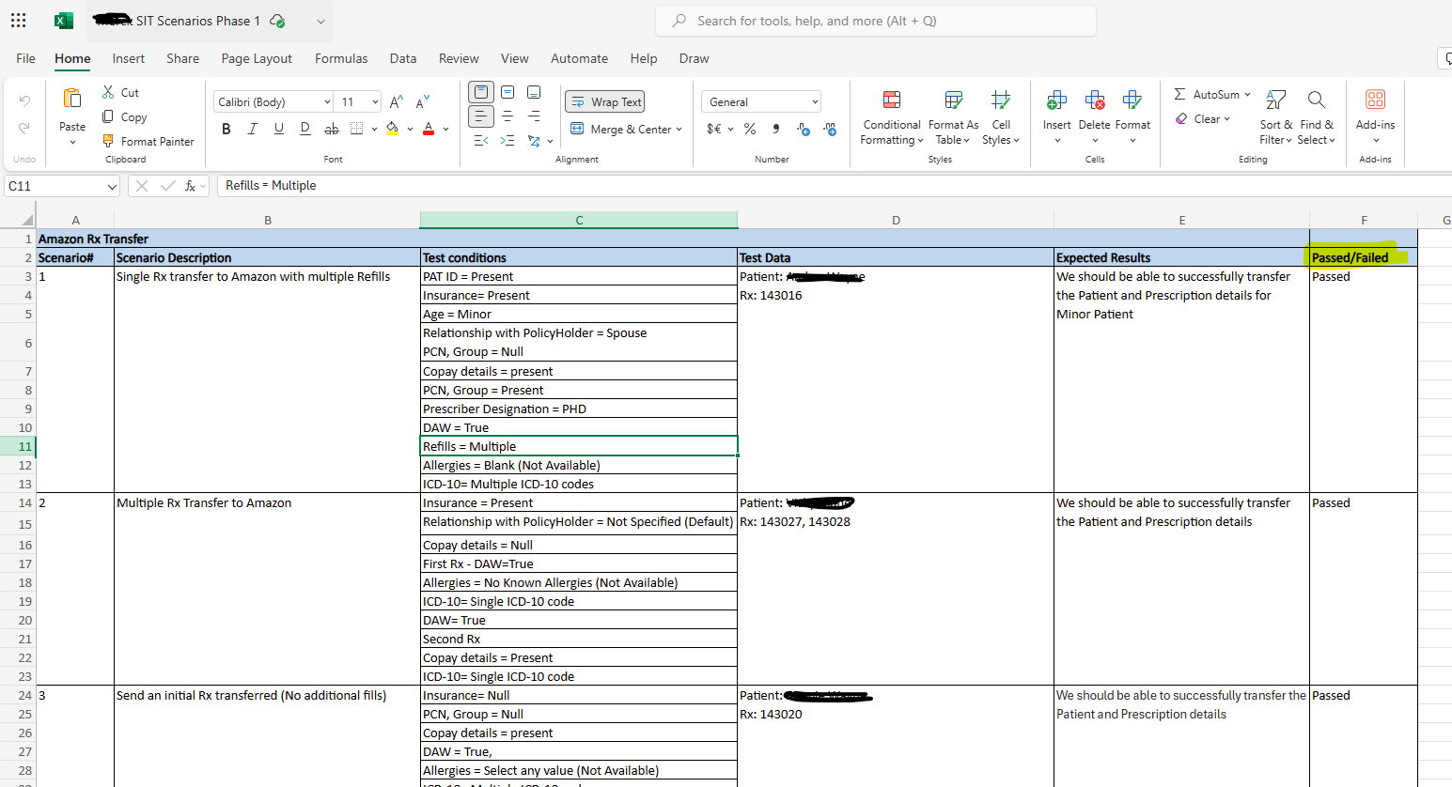

Screenshot of Production monitoring results

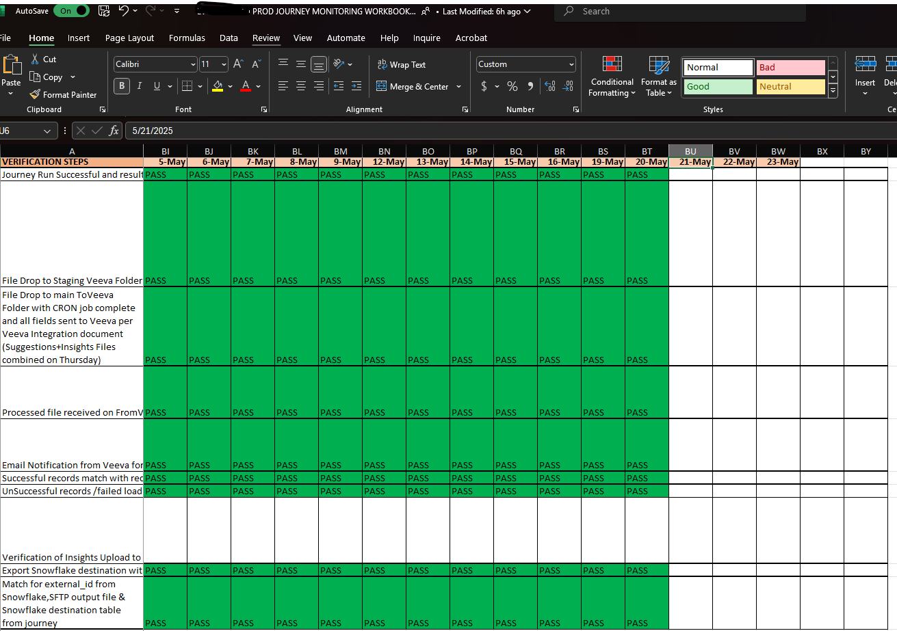

Screenshot of Tableau metrics match with Snowflake   
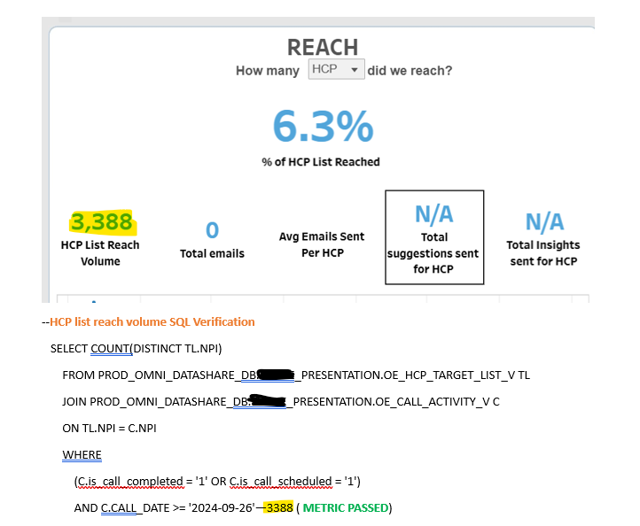

**4. Testing Objective for All Programs based on MODULE**

* Review the Strategic Activation document (SAD)
* Data Ingestion and Storing Snowflake (OE DWH)
* Destination Management Console
* GL Audience Builder
* GL Journey Builder
* ESP-Salesforce Marketing Cloud / Iterable
* Veeva Salesforce
* AWS Instances
* POSTGRES (Application DB)
* OE Media Activation
* Content Management – Tagging & Tracking
* AI NBE (Applied Insights Next Best Action)
* EMAIL ACTIVATION (Iterable/SFMC/EPSILON)
* Pharmacy Intake
* Digital Concierge (PWA)
* TELEHEALTH Platform
* Pharmacy Services (Ex: Amazon)
* ESS TABLEAU Reporting
* Web (GA4)
* Data Feeds

**5. Environments**

* (DEV/QA) is used for unit testing, and integration testing purposes
* STAGE environment is used for end-to-end scenario execution across systems, regression testing and performance testing.
* PROD environment is used for Client specific go-live activities. QA team used this environment for post-production monitoring.

**6. Testing Strategies**

Functional testing   
Functional testing involves verifying that each function of a software application works according to its specified requirements. This includes testing the user interface to provide appropriate inputs, check the outputs, and compare them against expected results.

Performance testing   
Performance testing involves evaluating a software application's speed, responsiveness, stability, and scalability under various workloads. It aims to identify performance bottlenecks and ensure the system can handle expected user loads and conditions.

Security testing   
Security testing involves assessing a software application, system, or network to identify vulnerabilities, weaknesses, and potential security threats. It aims to ensure that data and resources are protected from unauthorized access and malicious attacks.

Usability testing   
Usability testing involves evaluating a product's user interface and overall experience by observing real users as they interact with it. The goal is to identify any areas of confusion or difficulty, ensuring the product is intuitive and user-friendly.

System Integration testing   
Integration testing involves verifying the interactions and data exchange between different software modules or components. It aims to identify any issues that arise when these parts are combined and ensures they work together seamlessly.

Testing against SAD  
Ensuring all the criteria, global suppression rules, strategy for media/email activation is as expected between SAD and actual implementation.

Regression testing   
Regression testing involves re-running previously executed tests to ensure that recent code changes haven't adversely affected existing functionalities. It helps maintain software stability by identifying any new or reemerging bugs introduced during updates.  
  
End-to-end testing   
End-to-end testing involves validating the entire workflow of an application from start to finish to ensure all components work together seamlessly. This comprehensive approach tests the system in real-world scenarios to verify that it meets user expectations and business requirements.

Sanity Testing  
It is typically performed after minor changes or bug fixes to ensure that the critical functionalities are intact before proceeding with more extensive testing.

Smoke Testing  
Smoke testing involves running a set of preliminary tests on a new software build to verify that the most critical functions are working correctly.  It aims to quickly identify major issues and ensure the build is stable enough for further, more detailed testing.

**7. Outcomes**

* Documentation for test plan outlining the approach for testing.
* Documentation for each component verified against the requirements.
* Post- Production monitoring spreadsheet for active journeys.
* Tableau metrics verification document.
* Post-Production monitoring spreadsheet for live dashboards brand specific.
* Client Target file verification document that includes MDM, UDM and control & test split.
* Documentation for any issues or defects found during testing any of the components with accurate screenshots.
* Documentation for end-to-end scenarios across all systems in a prod like non-prod environment for QA signoff.
* Other supporting documents that might help the project.

**8. Communication Plan**

* Define roles and responsibilities within the testing team for each task.
* Establish a communication plan for the testing team to get daily updates on testing progress.
* Schedule regular meetings with Dev team to discuss progress any open issues.
* Maintain clear documentation of all communications.
* Inform the team on new activations that were signed off successfully by QA and ready to go-live for visibility.
* Inform first responder on any production issue on necessary measures to be taken.